Cognitive Test (2)
Name: __________________________________________ Total: ______/41

- The three key Nazi aims for Germany after 1933 were: (3m)

- _______________________________________________
- _______________________________________________
- _______________________________________________

- How might each of the following help the Nazis achieve their aims? (2m)

- A single party state __________________________________________________
________________________________________________________________________
- Propaganda ________________________________________________________
________________________________________________________________________

- What were the following? (6m)

- Night of the Long Knives _______________________________________________
- Autarky _____________________________________________________________
- ‘Burning of the Books’ _________________________________________________
- “Degenerate Art” _____________________________________________________
- Autobahns ___________________________________________________________
- Hitler Jugend ________________________________________________________

- What role did the following people undertake in 1930s Germany? (5m)
- Roehm ______________________________________________________________
- Himmler _____________________________________________________________
- Schacht ______________________________________________________________
- Goering ______________________________________________________________
- Goebbles ____________________________________________________________

- What impact did the following have on German society in the 1930s? (6m)
Event/Issue | Positive/Negative/Both? | Explanation
The House of German Art
The Reich Chamber of Culture
‘Strength Through Joy’
Degenerate Art Exhibition

“Arms not butter”
League of German Maidens

- What were the key aims of the ‘New Plan’ introduced to the economy in the early 1930s? (2m)
__________________________________________________________________________________________________________________________________________________________________________________________________________________________________________

- Define the following terms: (4m)
- Holocaust _______________________________________________________________
- Aryan __________________________________________________________________
- Master Race _____________________________________________________________
- Shoah __________________________________________________________________

- In the space below re write the following events of the Holocaust in their correct chronological order from earliest event in Nazi Germany to the latest. USE LETTERS. (4m)
Kristallnacht (K) Warsaw Ghetto (WG) Nuremburg Laws(NL)
Building of gas chambers (G) Burning of the Books(BB) Wannsee Conference (WC)
Wearing of the Yellow Star (YS) Boycott of Jewish shops (JS)

Earliest Latest
Event Event

- Describe the impact of World War Two in Germany to 1945.
[Consider: impact on women, youth; role of propaganda, rationing; impact of ‘total war’, air raids, defeat.]
____________________________________________________________________________________________________________________________________________________________________________________________________________________________________________________________________________________________________________________________________________________________________________________________________________________________________________________________________________________________________________________________________________________________________________________________________________________________________________________________________________________________________________________________________________________________________________________________________________________________________________________________________________________________________________________________________________________________________________________________________________________________________________________________________________________________________________________________________________________________________________________________________________________________________________________________________________________________________________________________________________________________________________________________________________________________________________________________________________________________________________________________________(6m)

- Annotate the cartoon from the anti-Jewish German newspaper, Der Sturmer. (3m)
“Away with Him” March 1933 (Issue #12)

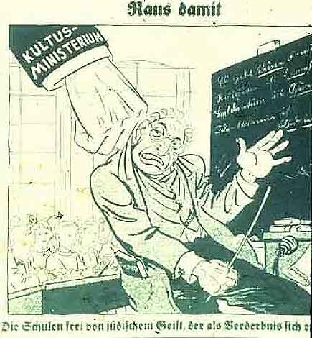

End of Test.

